### **Global Malnutrition Trends: A Power BI Analysis (1983-2019)**

**Introduction :**

ABC Company is undertaking an in-depth analysis of global malnutrition trends from 1983 to 2019 to better understand the prevalence and distribution of various forms of malnutrition among children under five years of age. Utilizing a comprehensive dataset from UNICEF/WHO/World Bank, the project aims to analyze severe wasting, wasting, stunting, underweight, and overweight conditions across different countries. By classifying countries according to their income levels (low, lower-middle, upper-middle, and high income) and other categories such as Least Developed Countries (LDC), Low Income Food Deficient (LIFD), Land Locked Developing Countries (LLDC), and Small Island Developing States (SIDS), the project seeks to uncover correlations between economic status and malnutrition rates. Through the use of advanced data visualization techniques in Power BI, including stacked bar charts and line charts, ABC Company aims to generate actionable insights that can guide policy-making and resource allocation to combat child malnutrition effectively.

Malnutrition remains a critical global health issue, with children in lower-income countries disproportionately affected. ABC Company aims to address the challenge of identifying key patterns and trends in child malnutrition data over several decades. The primary problem is to determine how various forms of malnutrition correlate with economic and geographical classifications of countries, and to identify which countries and regions are most affected. By leveraging historical data, the project will highlight areas needing urgent attention and support, helping stakeholders to prioritize interventions and strategies for reducing malnutrition and its associated health risks among children under five. This analysis is crucial for developing targeted, data-driven solutions to improve child health outcomes worldwide.

Scenario 1: Count of U5 Population (140)

This metric represents the number of observations related to the under-five population in the dataset. It indicates the sample size or the count of data points collected.

Scenario 2: Sum of Survey Sample (11M)

The total sum of survey samples collected is 11 million. This large sample size adds robustness to the analysis and findings, ensuring that the insights derived are based on a substantial amount of data.

Scenario 3: Sum of Underweight (2.08K)

The total number of underweight cases is 2,080. This highlights the prevalence of underweight conditions among children under five, which is a critical aspect of malnutrition to address.

Scenario 4: Sum of LDC,LIFD,LLDC or SID2 and Average of Stunting by Income Analysis

The visualization is about the average spending by income. The x-axis shows income classification, likely divided into segments, and the y-axis shows the average spending. There is a trend line that shows that as income classification goes up, average spending also goes up.

Scenario 5: Sum of Overweight by Country

The visualization is about the total number of overweight people in various countries, according to a dataset titled "Sum of Overweight".

Scenario 6: Sum of Overweight and Underweight under Income Classification.

The width of each ribbon segment (overweight or underweight) for a specific income level indicates the relative size of that population group within that income bracket. By following the ribbon's path, you can see if overweight or underweight populations become more or less dominant as income levels change.

Scenario 7: Sum of Income Classification

It represents the total income within each income bracket, but without knowing the number of people in each bracket, it's difficult to interpret. A high total could be due to a few very high earners or many people with moderate incomes. Labels for each income bracket (e.g., low, middle, high).

**Technical Architecture:**

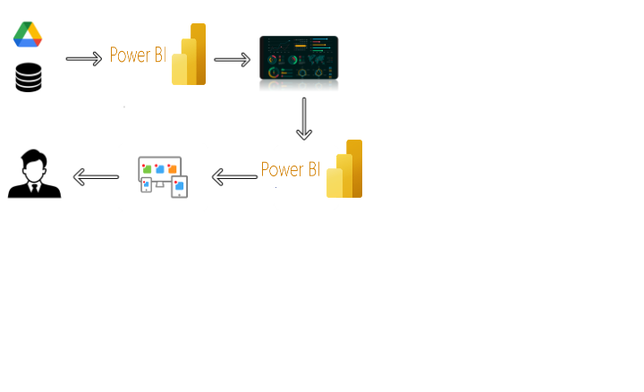

**Project Flow**

To accomplish this, we have to complete all the activities listed below,

* Data Collection & Extraction from Database
  + Collect the dataset,
  + Storing Data in DB
  + Perform SQL Operations
  + Connect DB with Power Bi
* Data Preparation
  + Prepare the Data for Visualization
* Data Visualizations
  + No of Unique Visualizations
* Dashboard
  + Responsive and Design of Dashboard
* Report
  + Responsive and Design of Dashboard
* Performance Testing
  + No of Visualizations/ Graphs

**Milestone 1: Data Collection & Extraction from Database**

Data collection is the process of gathering and measuring information on variables of interest, in an established systematic fashion that enables one to answer stated research questions, test hypotheses, and evaluate outcomes and generate insights from the data.

**Activity 1: Download the data**

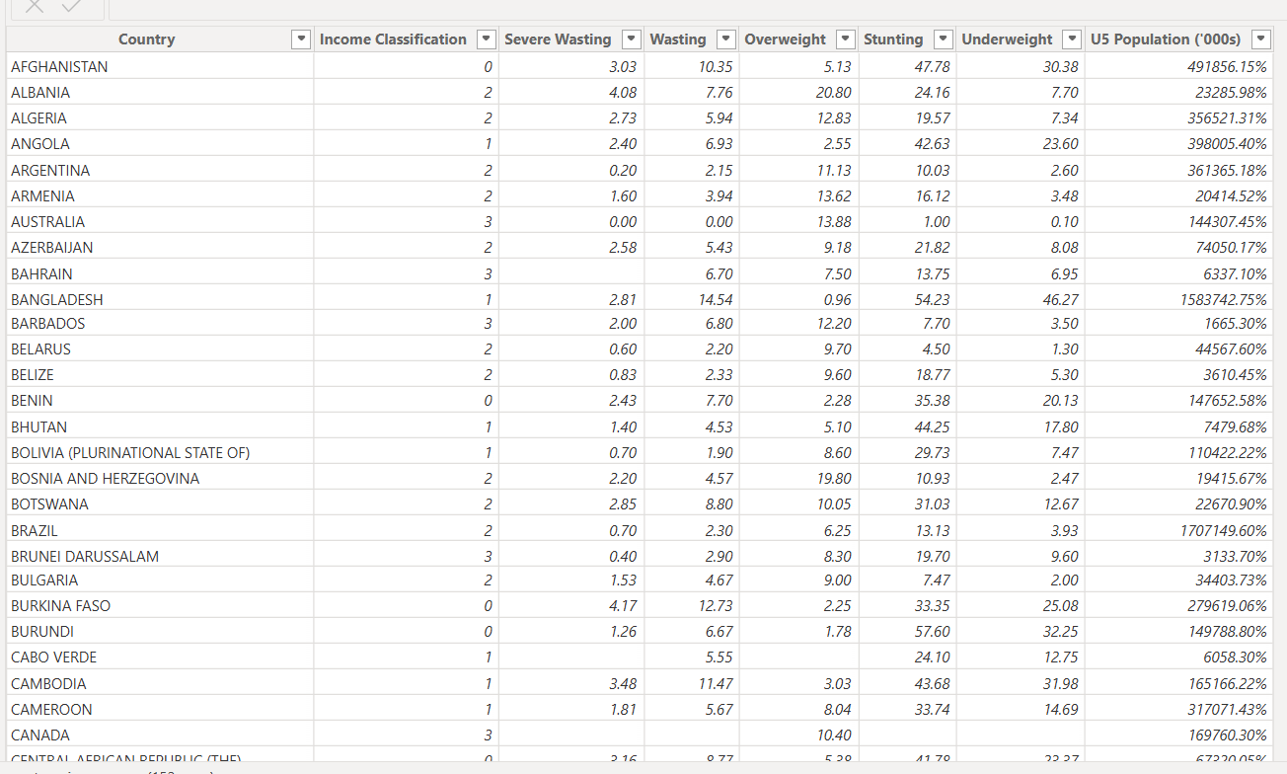

**Activity 2:Understand the dataset**

Data contains all the meta information regarding the columns described in the CSV files

Column Description of the Dataset:

* **ISO code**: Standardized two-letter country codes.
* **Country:** Name of the country.
* **Survey Year**: The year in which the survey data was collected.
* **. Year**: The specific year of the data point.
* **Income Classification**: Income classification of countries (0: Low Income, 1: Lower Middle Income, 2: Upper Middle Income, 3: High Income).
* **LDC**: Indicator for Least Developed Countries (LDCs).
* **LIFD**: Indicator for Low Income Food Deficient (LIFD) countries.
* **LLDC or SID2:** Classification for Land Locked Developing Countries (1), Small Island Developing States (2), and Others (0).
* **Survey Sample (N):** The size of the survey sample.
* **Severe Wasting**: Average percentage of children with severe wasting.
* **Wasting:** Average percentage of children with wasting.
* **Overweigh**t: Average percentage of overweight children.
* **Stunting:** Average percentage of children with stunting.
* **Underweight**: Average percentage of underweight children.
* **U5 Population ('000s):** Population of children under five years old (in thousands).

**Activity 2: Connect Data with Power BI**

With Power BI, users can seamlessly connect to a wide range of data sources, including databases, cloud services, spreadsheets, and streaming data. This capability allows organizations to consolidate disparate data sources into a single, unified platform, breaking down data silos and enabling holistic analysis.

**Milestone 2: Data Preparation**

Data preparation is a critical phase in the data lifecycle, encompassing activities that transform raw data into a format suitable for analysis. This multifaceted process involves several steps including data cleaning, integration, transformation, and enrichment.

**Data Loading:**

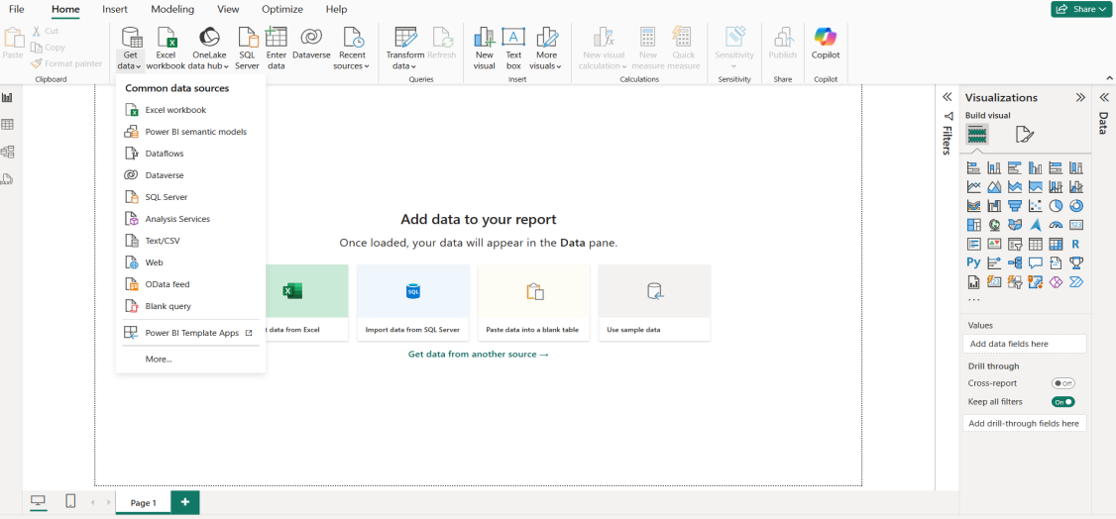

**Data Cleaning:**

. Data cleaning involves identifying and rectifying errors, inconsistencies, and missing values within datasets to ensure accuracy and reliability.

**Cleaning by deleting the zero values:**

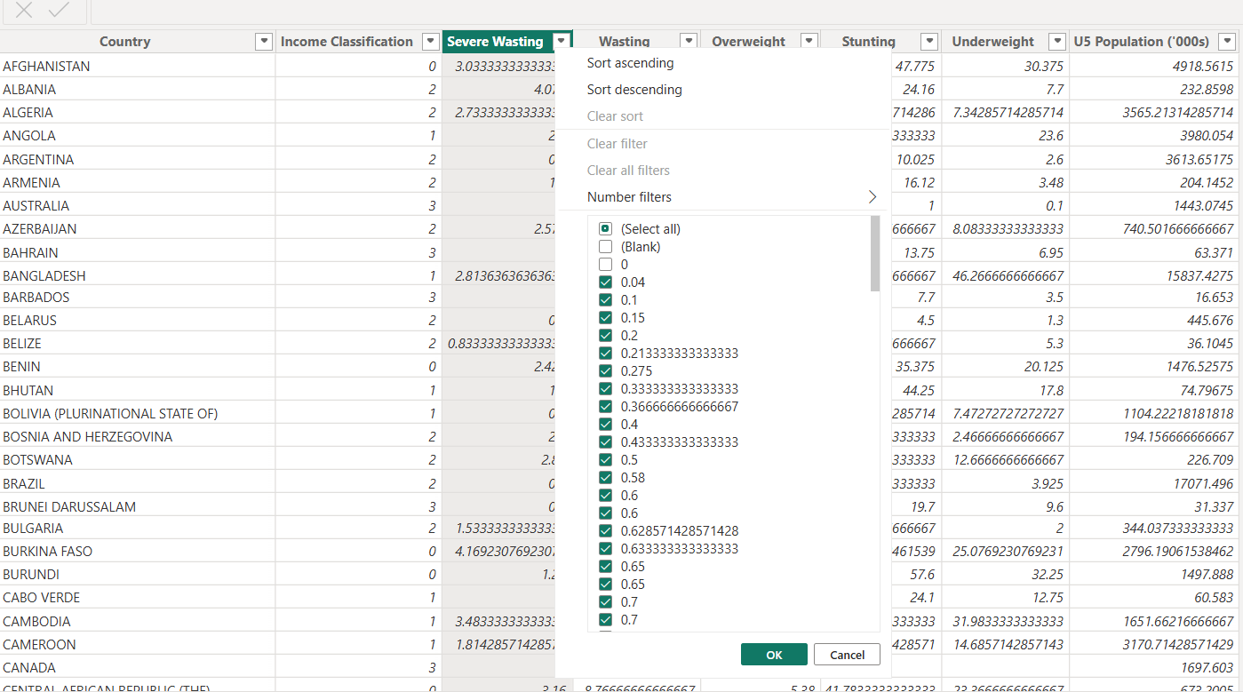

Fig:1.6: Deselecting the zero values

**Converting decimal values to fixed decimal values:**

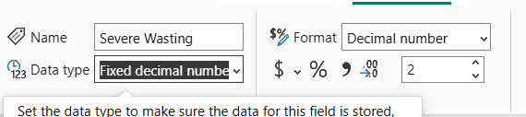

**Milestone 3: Data Visualization**

Data visualization is the process of creating graphical representations of data to help people understand and explore the information. The goal of data visualization is to make complex data sets more accessible, intuitive, and easier to interpret. By using visual elements such as charts, graphs, and maps, data visualizations can help people quickly identify patterns, trends, and outliers in the data.

**Activity 1.1: Count of U5 Population**

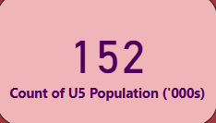

**Activity 1.2: Sum of Survey Sample**

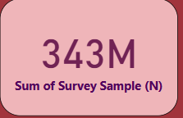

**Activity 1.3: Sum of Underweight**

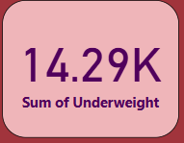

**Activity 1.4:  Sum of LDC,LIFD,LLDC or SID2 and Average of Stunting by Income Analysis**

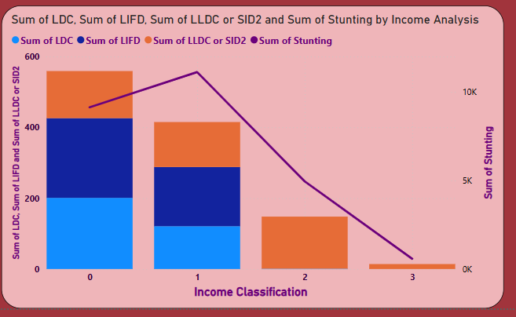

**Activity 1.5:  Sum of Overweight by Country**

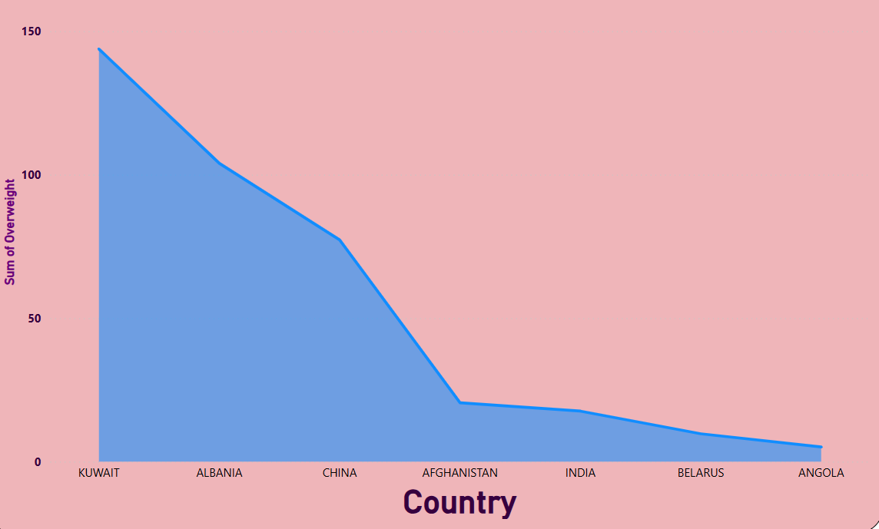

**Activity 1.6: Sum of Overweight and Underweight under Income Classification.**

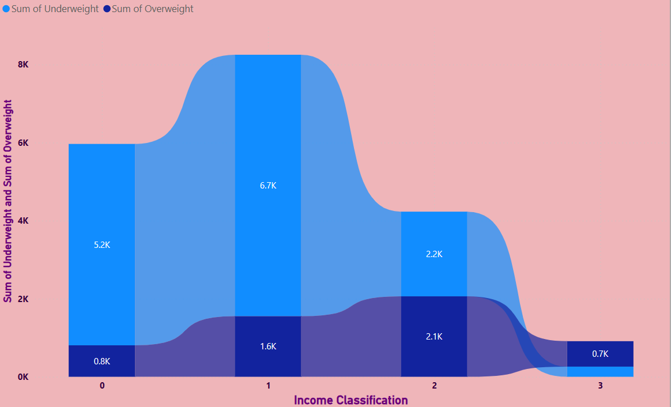

**Milestone 5: Dashboard**

A dashboard is a graphical user interface (GUI) that displays information and data in an organized, easy-to-read format. Dashboards are often used to provide real-time monitoring and analysis of data and are typically designed for a specific purpose or use case. Dashboards can be used in a variety of settings, such as business, finance, manufacturing, healthcare, and many other industries. They can be used to track key performance indicators (KPIs), monitor performance metrics, and display data in the form of charts, graphs, and tables.

**Activity :1- Responsive and Design of Dashboard**

The responsiveness and design of a dashboard for global malnutrition trends from 1983 to 2019 .

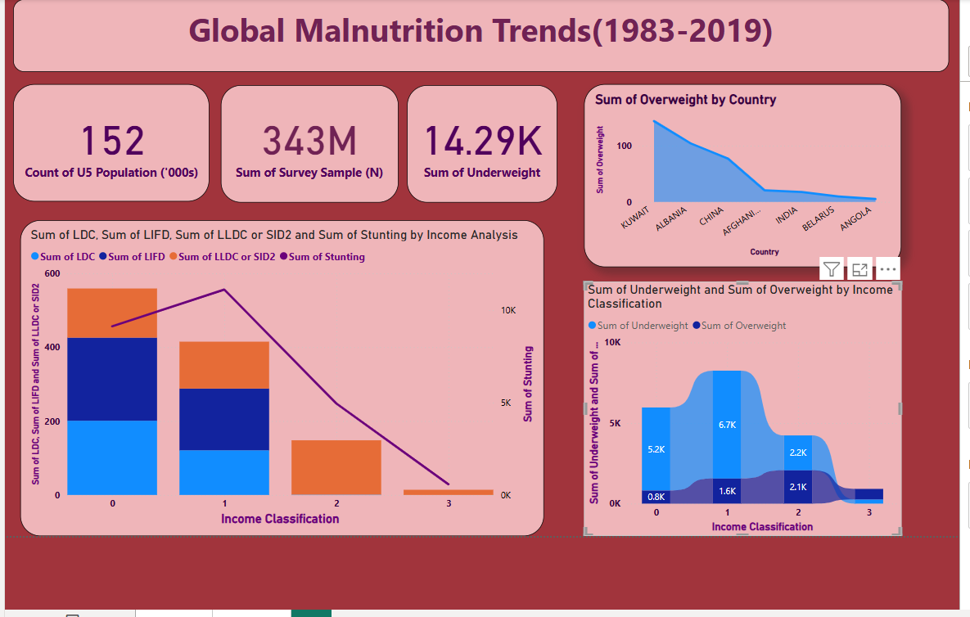

**Milestone 6: Report**

A report is a comprehensive document that provides a detailed and structured account of data analysis, findings, and insights. It is typically used for in-depth analysis, documentation, and communication of results. Reports are suitable for a diverse audience, including decision-makers, analysts, and stakeholders who need a comprehensive understanding of the data.   
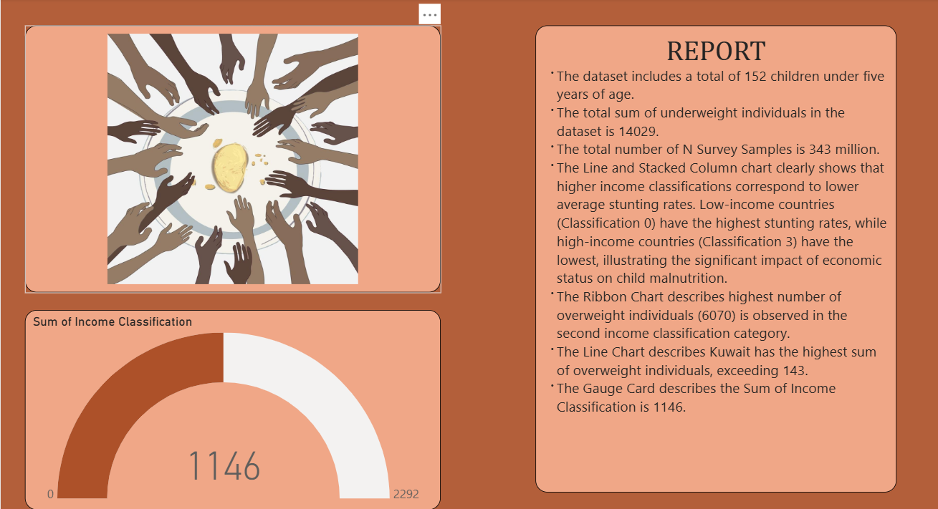**Milestone 7: Performance Testing**

Performance testing in Power BI for global malnutrition trends (1983-2019) ensures efficient data processing, report loading, and responsiveness. It evaluates data load performance, DAX query efficiency, and report rendering speed. Key optimizations include using aggregations, optimizing data models, and reducing visual complexity. Monitoring CPU/memory usage and enhancing user interaction responsiveness improve performance. These strategies ensure scalable, fast, and insightful analysis for policymakers and researchers.

### **Activity 1:Amount of Data Loaded**

Amount of Data Loaded" refers to the quantity or volume of data that has been imported, retrieved, or loaded into a system, software application, database, or any other data storage or processing environment. It's a measure of how much data has been successfully processed and made available for analysis, manipulation, or use within the system.

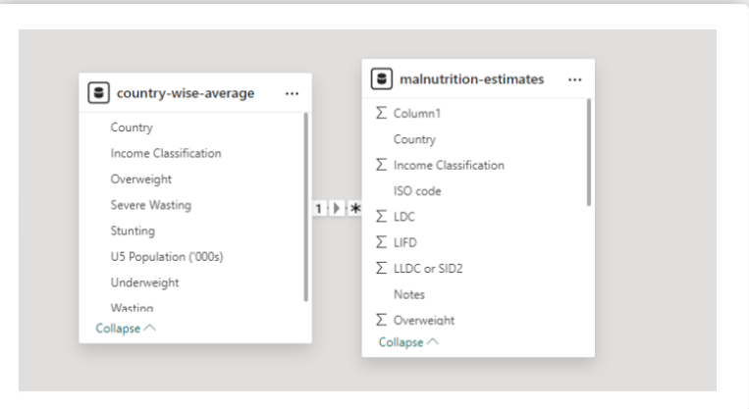

### **Activity 2:Utilization of Filters**

"Utilization of Filters" refers to the application or use of filters within a system, software application, or data processing pipeline to selectively extract, manipulate, or analyze data based on specified criteria or conditions.

Activity 2.1: Selected “Country” as a Filter’

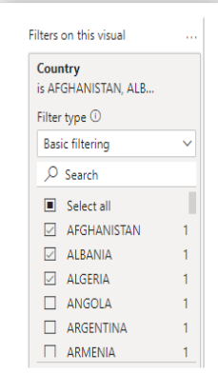

### **Activity 3: No of Visualizations/ Graphs**

* Count of U5 Population
* Sum of Survey Sample(N)
* Sum of Underweight
* Sum of Overweight by Country
* Total Income Classification
* Sum of Overweight and Underweight by Income Classification
* Sum of LDC, LIFD, LLDC or SID2 and Average of  Stunting by Income Analysis